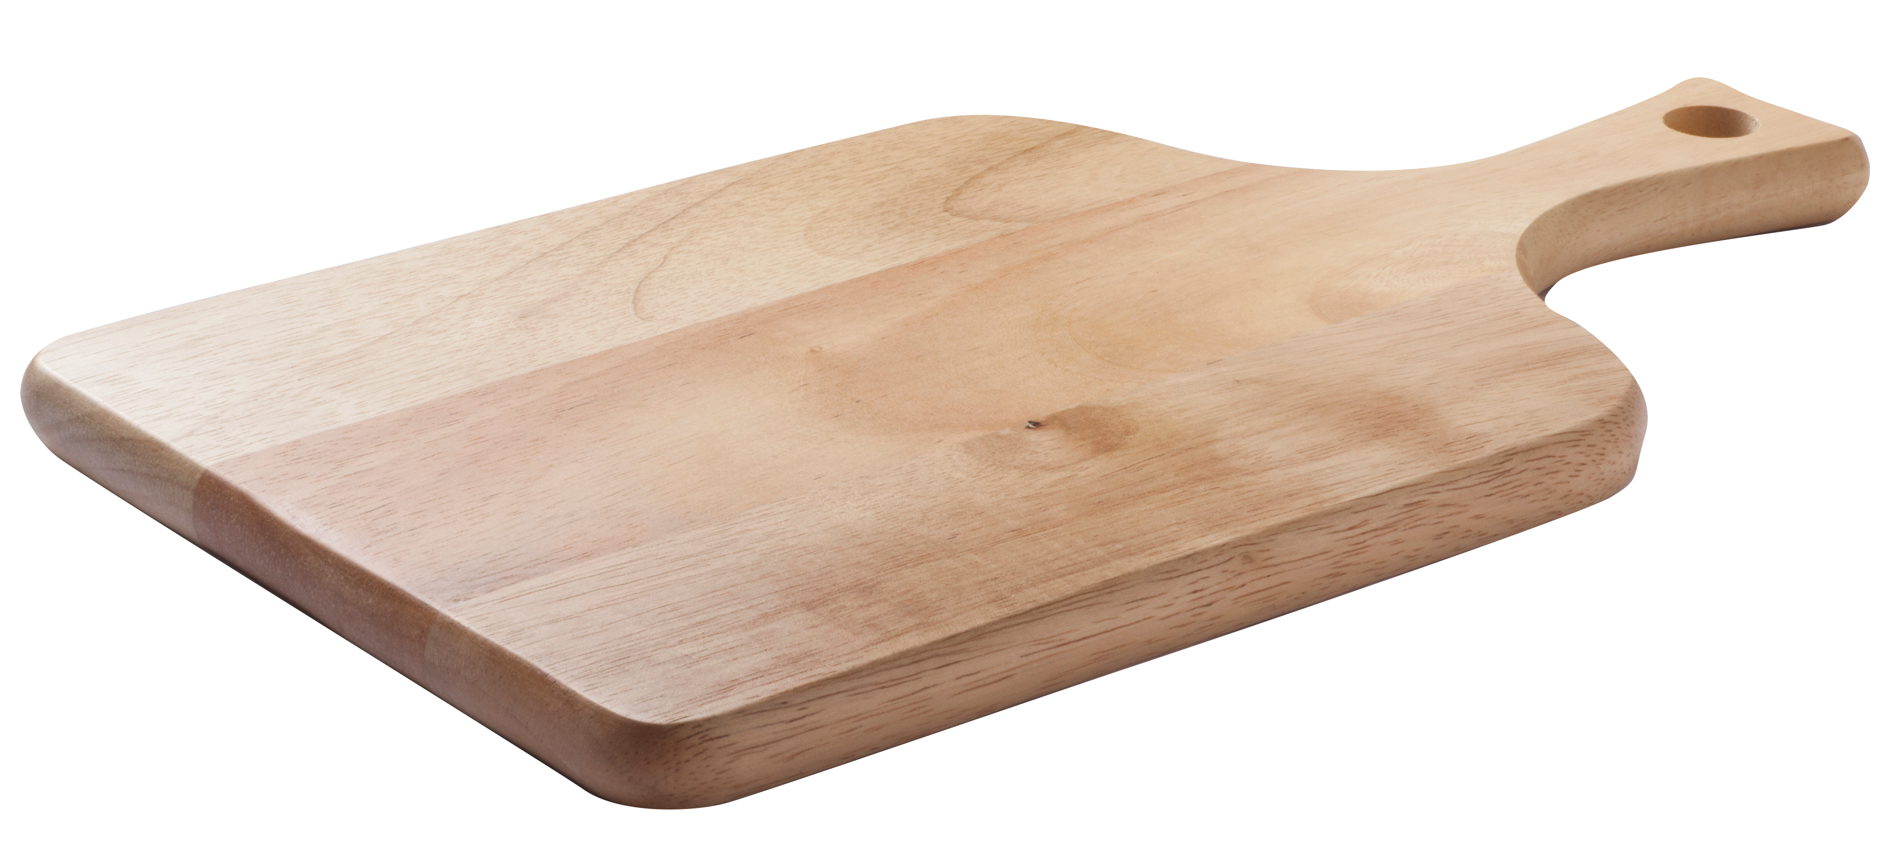

weekly menu

SERVED DAILY:

Grilled Chicken Breast •

Turkey Burger •

Veggie Burger •

Vegetable Plate •  
(3 choices)

GREEN

YELLOW

RED

Choose MORE often

Choose in MODERATION

Choose LESS often

Monday, March 5

Thursday, March 8

Tuesday, March 6

Friday, March 9

Wednesday, March 7

MOM’S SOUP BOWL:

• Minestrone 3.00

• Texas Chili 3.40

healthy habits:

• Sweet & Sour Grilled

Chicken over Rice 6.25

chef’s market:

• Pork Fritter w/ 1 Side 6.25

grill:

• Tuna Melt 5.95

sides:

• Rice 1.50

• Mixed Veggies 1.45

daily special:

• Tuna Melt, Chips, &

20 oz. Fountain Drink 6.25

MOM’S SOUP BOWL:

• Chicken & Dumplings 3.00

• Texas Chili 3.40

healthy habits:

• Southwest Chicken & Rice   
Stuffed Bell Pepper 5.20

chef’s market:

• Cannelloni 5.20

sides:

• Green Beans 1.50

• Mixed Vegetables 1.45

daily special:

• Crispy Shrimp, Fries, &

20oz Fountain Drink 6.25

MOM’S SOUP BOWL:

• Loaded Baked Potato 3.00

• Texas Chili 3.40

made to order:

• Syberg’s Crispy   
Chicken Tender Salad 6.30

healthy habits:

• Lean Roast Beef 5.20

with 1 Side 6.25

Grill:

• Fried Cod Sandwich with

Cheese 5.75

sides:

• Mashed Potatoes 1.50

• Corn & Peppers 1.45

daily special:

• Turkey Burger, Homemade

Chips, and 20oz. Fountain

Drink 6.25

MOM’S SOUP BOWL:

• Tomato Soup 3.00

• Texas Chili 3.40

made to order:

• Chicken Fajitas 6.30

healthy habits:

• Mediterranean Marinated Chicken Breast with Tomatoes 5.20

Grill:

• Polish Sausage w/ Peppers   
and Onions on a Bun 4.50

sides:

• Fresh Vegetable 1.45

• Spanish Rice 1.50

daily special:

• Grilled Cheese, Chips, and

20oz. Fountain Drink 5.75

MOM’S SOUP BOWL:

• Chicken Noodle 3.00

• Texas Chili 3.40

healthy habits:

• Grilled Pork Chop 5.20

chef’s market:

• Fried Cod 6.25

Deli Special:

• Build Your Own Two

Topping Personal Pizza 5.95

sides:

• Fresh Mixed Vegetables 1.45

• Mac and Cheese 1.50

daily special:

• Grilled Chicken Sandwich House Made Chips and  
20oz. Fountain Drink 6.25

The CityPlace Cafe

Food service and catering by: